CSS
- CSS stands for Cascading Style Sheets

CSS describes how HTML elements are to be displayed on screen, paper, or in other media
- CSS saves a lot of work. It can control the layout of multiple web pages all at once
- External stylesheets are stored in CSS files

Importance of CSS
HTML was NEVER intended to contain tags for formatting a web page! HTML was created to describe the content of a web page, like:
<h1>This is a heading</h1>

<p>This is a paragraph.</p>

When tags like <font>, and color attributes were added to the HTML 3.2 specification, it started a nightmare for web developers. Development of large websites, where fonts and color information were added to every single page, became a long and expensive process.

To solve this problem, the World Wide Web Consortium (W3C) created CSS. CSS removed the style formatting from the HTML page!

Use of CSS

A CSS rule-set consists of a selector and a declaration block:
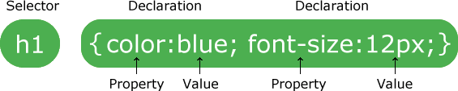
The selector points to the HTML element you want to style.
The declaration block contains one or more declarations separated by semicolons. Each declaration includes a CSS property name and a value, separated by a colon.
Multiple CSS declarations are separated with semicolons, and declaration blocks are surrounded by curly braces.

Example
In this example all <p> elements will be center-aligned, with a red text color:

p {

color: red;

text-align: center;
}

Code | Output
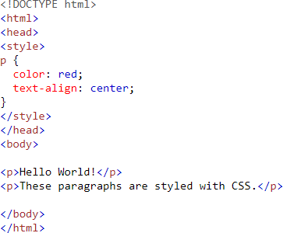 | 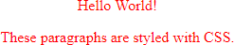

- p is a selector in CSS (it points to the HTML element you want to style: <p>).
- color is a property, and red is the property value
- text-align is a property, and center is the property value

CSS Selectors

CSS selectors are used to "find" (or select) the HTML elements you want to style.We can divide CSS selectors into five categories:

- Simple selectors (select elements based on name, id, class)
- Combinator selectors (select elements based on a specific relationship between them)
- Pseudo-class selectors (select elements based on a certain state)
- Pseudo-elements selectors (select and style a part of an element)
- Attribute selectors (select elements based on an attribute or attribute value)

Table of CSS Selectors
Category | Selector Type | Definition | Explanation | Example CSS | Example HTML
Simple Selector | Element Selector | Selects HTML elements based on tag name. | Applies style to all elements of that type. | p { color: blue; } | <p>This is a paragraph</p>
Simple Selector | Class Selector | Selects elements with a specific class. | Multiple elements can share the same class. | .box { background-color: yellow; } | <div class='box'>Content</div>
Simple Selector | ID Selector | Selects element with a specific id. | ID is unique in a page. | #header { color: red; } | <h1 id='header'>Welcome</h1>
Simple Selector | Universal Selector | Selects all elements. | Often used for reset styling. | * { margin:0; padding:0; } | Applies to all elements
Simple Selector | Group Selector | Selects multiple elements together. | Same style applied to several elements. | h1, h2, p { color: green; } | <h1>Title</h1> <p>Text</p>
Combinator Selector | Descendant Selector | Selects elements inside another element. | Targets nested elements. | div p { color: blue; } | <div><p>Text</p></div>
Combinator Selector | Child Selector | Selects direct children of an element. | Only immediate child affected. | div > p { color: red; } | <div><p>Child</p></div>
Combinator Selector | Adjacent Sibling | Selects element immediately after another. | Only first next sibling selected. | h1 + p { color: green; } | <h1>Title</h1><p>Paragraph</p>
Combinator Selector | General Sibling | Selects all siblings after an element. | All following siblings affected. | h1 ~ p { color: purple; } | <h1>Title</h1><p>Text1</p><p>Text2</p>
Pseudo-class Selector | :hover | Selects element when mouse is over it. | Used for interactive effects. | a:hover { color: red; } | <a href='#'>Link</a>
Pseudo-class Selector | :active | Selects element while being clicked. | Useful for button effects. | button:active { background: gray; } | <button>Click</button>
Pseudo-class Selector | :focus | Selects element when focused. | Used for inputs and forms. | input:focus { border:2px solid blue; } | <input type='text'>
Pseudo-class Selector | :nth-child() | Selects elements based on position. | Targets numbered elements. | li:nth-child(2) { color:red; } | <li>One</li><li>Two</li>
Pseudo-element Selector | ::before | Inserts content before element. | Often used for icons or notes. | p::before { content:'Note:'; } | <p>Important text</p>
Pseudo-element Selector | ::after | Inserts content after element. | Adds symbols or decorations. | p::after { content:'✓'; } | <p>Completed</p>
Pseudo-element Selector | ::first-letter | Styles first letter. | Used in articles. | p::first-letter { font-size:30px; } | <p>Hello world</p>
Pseudo-element Selector | ::first-line | Styles first line. | Depends on text wrapping. | p::first-line { color:blue; } | <p>Long paragraph...</p>
Attribute Selector | [attribute] | Selects elements with attribute. | Targets elements containing attribute. | a[target] { color:red; } | <a target='_blank'>Link</a>
Attribute Selector | [attribute=value] | Selects attribute with exact value. | Targets exact match. | input[type='text'] { border:1px solid black; } | <input type='text'>
Attribute Selector | [attribute~=value] | Selects attribute containing word. | Useful for multi-value attributes. | [title~='flower'] { color:blue; } | <p title='red flower'>Text</p>
Attribute Selector | [attribute^=value] | Selects attribute starting with value. | Targets prefixes. | a[href^='https'] { color:green; } | <a href='https://site.com'>Link</a>
Attribute Selector | [attribute$=value] | Selects attribute ending with value. | Targets file types etc. | a[href$='.pdf'] { color:red; } | <a href='file.pdf'>PDF</a>

Inline, Internal and External Styles
There are three places where you can define style rules:
Inline Style: Included inside a particular HTML opening tag's via attribute style="style-rules". The rules are applicable to that particular HTML element only.
Internal (Embedded) Style Sheet: Embedded inside the <style>...</style> tags in the HEAD section of the HTML document. The styles are applicable to that entire document.
External Style Sheet: Stored in an external file, which is then linked to HTML documents via a <link> element in the HEAD section. The same external style sheet can be applied to all HTML pages in your website to ensure uniformity in appearance.

Inline Styles
To apply inline style to an HTML element, include the list of style properties in the style attribute of the opening tag. For example,
<!DOCTYPE html>
<html>
<body>
<p style="font-size:18px; font-family:cursive">This paragraph uses 18px cursive font.</p>
<p>This paragraph uses default font.</p>
<p>This
span</span>
paragraph
uses <span style="font-size:20px">20px inside this
but default font size here.</p>
</body>
</html>

Internal (Embedded) Styles
Embedded styles are defined within the <style>...</style> tags in the HEAD section. For example,
<!DOCTYPE html>
<html>
<head>
<style>
body
h2
{ background-color:cyan }
{ color:white; background-color:black }
p.cursive { font-size:18px; font-family:cursive }
p.f20px { font-size:20px }
</style>
</head>
<body>
<h2>H2 is white on black</h2>
<p>This paragraph is normal.</p>
<p class="cursive">This paragraph uses 18-px cursive font.</p>
<p class="f20px">This paragraph uses 20-px font.</p>
</body>
</html>
- The scope of the embedded styles is the current HTML document.
- Embedded styles separate the presentation and content (in the HEAD and BODY sections) and can be used if page-to-page uniformity is not required. That is, this set of styles is used for only one single page!?

External Styles
The style rules are defined in an external file, and referenced in an HTML document via the <link> element in the HEAD section.
For example, we define these style rules in a file called "TestExternal.css":
/* testExternal.css */
body
h2 p
{ background-color:cyan; color:red; }
{ background-color:black; color:white; text-align:center; }
{ font-size:12pt; font-variant:small-caps; }
p.f24pt { font-style:italic; font-size:24pt; text-indent:1cm; }
#green { color:green; }

This HTML document references the external style sheet via the <link> element in the HEAD section:
<!DOCTYPE html>
<html lang="en">
<head>
<meta charset="utf-8">
<link href="TestExternal.css" rel="stylesheet">
</head>
<body>
<h2>H2 is white on black</h2>
<h2 id="green">This H2 is green on black</h2>
<p>The default paragraph uses 12-pt small-cap font.</p>
<p class="f24pt">This paragraph uses 24-pt, italics font with text-indent of 1cm.
It inherits the small-cap property from the default paragraph selector.</p>
</body>
</html>
You can use multiple <link> elements to include multiple CSS files.
The main advantage of external style sheets is that the same set of styles can be applied to all HTML pages in your website to ensure uniformity in presentation. External style sheet is the now-preferred approach.Inline styles have the highest priority, followed by internal styles, and followed by external styles.

Box Model
The CSS box model consists of four layers: content, padding, border, and margin.
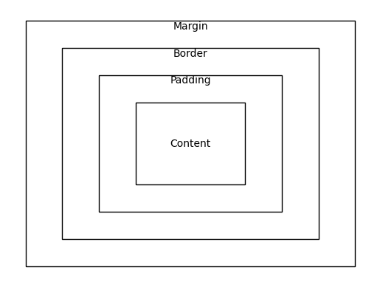

A block element (such as <p>, <div>, <h1> to <h6>) is always rectangular in shape and exhibits the so- called box model, with four virtual rectangles wrap around its "content area", representing the content area, padding, border, margin, as illustrated below.

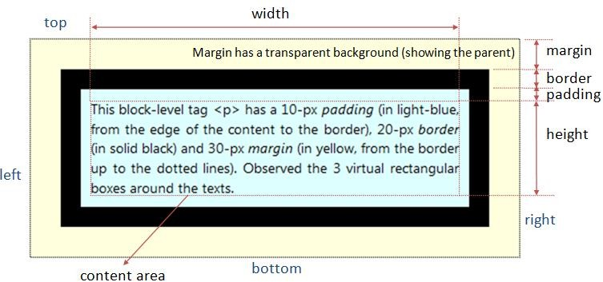

- The content area contains the texts, image, or child elements.
- The padding is the space between the content area and the border. It clears an area outside the content area. It has the same background as the content area.
- The border goes between padding and margin. You can set a color and a style (such as solid, dash, dotted) to the border.
- The margin is the space outside the border (to another element). It clears an area outside the border. The margin does not have a background, and is totally transparent.
As illustrated in the box model diagram, margin pushes its border (and content) away with a transparent background showing the parent (having the effect of pushing itself away from the parent); while padding pushes its content inwards with the same background. Margin and padding serve the same purpose if there is no border and background applied.
Take note that the width and height that you set for the element specify its content area, exclude the margin, border and padding. To get the actual size of the element, you need to add the margin, border and padding to the width/height. For example, suppose that:
#elm {
width: 300px; margin: 10px;
border: 5px solid black; padding: 20px;
}
The actual width of the element is 300+(10+5+20)x2 = 370px.
Each of the rectangular bounds has four sides, and can be individually referred to as xxx-top, xxx- right, xxx-bottom, and xxx-left in a clockwise manner, where xxx could be margin, border or padding. The four sides can be controlled individually or as a group.

CSS Margin, Border and Padding Properties

Property Group | Property | Possible Values / Syntax | Description / Explanation | Example
Margin | margin-top, margin-right, margin-bottom, margin-left | auto | n | n% | Sets individual margins. n is a unit (px, em). Negative values can overlap elements. % relative to parent. | margin-top:10px; margin-left:-20px;
Margin | margin (shorthand - 4 values) | margin: top right bottom left | Sets all four margins clockwise. | margin:10px 20px 30px 40px;
Margin | margin (shorthand - 2 values) | margin: top-bottom left-right | Top & bottom share first value, left & right share second. | margin:10px 20px;
Margin | margin (shorthand - 1 value) | margin: value | Applies same margin to all four sides. | margin:15px;
Padding | padding-top, padding-right, padding-bottom, padding-left | n | n% | Sets individual paddings. Padding is space inside the border. | padding-top:10px; padding-left:5%;
Padding | padding (shorthand - 4 values) | padding: top right bottom left | Sets padding clockwise. | padding:5px 10px 5px 10px;
Padding | padding (shorthand - 2 values) | padding: top-bottom left-right | Top & bottom share first value. | padding:10px 20px;
Padding | padding (shorthand - 1 value) | padding: value | Applies same padding to all sides. | padding:15px;
Border | border-width | thin | medium | thick | n | Defines thickness of borders. Can be applied individually (border-top-width etc.). | border-width:2px;
Border | border-style | none | hidden | dotted | dashed | solid | double | groove | ridge | inset | outset | Defines visual style of border. | border-style:solid;
Border | border-color | #rrggbb | rgb() | rgba() | color-name | Defines color of border. | border-color:red;
Border | border (shorthand) | border: width style color | Sets border width, style, and color in one line. | border:2px solid blue;
Border | border-top / border-right / border-bottom / border-left | border: width style color | Apply border settings to individual sides. | border-top:3px dashed green;
Inheritance | Inheritance Rule | — | Margin, border, padding, and width are NOT inherited by child elements. | —

CSS Position
Each element has a natural location inside a page's flow, in the order read in by the browser. The property position can be used to alter the position of block elements.

position: static|absolute|relative|fixed
By default, elements are displayed from top to bottom in the normal flow. For block elements, line breaks are inserted at the beginning and the end to form a rectangular box. You can leave the box in the default normal flow (position:static); you can remove the box from the normal flow and specify its location with respect to either its parent element (position:absolute) or the browser window (position:fixed); you can also move the box with respect to its normal position in the flow (position:relative).
For non-static positioned elements, the new position is specified via top, left, bottom, right, width, height properties:

top: n|n%|auto left: n|n%|auto bottom: n|n%|auto right: n|n%|auto
Set the distance from the edge of this element to the corresponding edge of the containing block.

width: n|n%|auto height: n|n%|auto
Set the width and height of this block. You can use the width and height to scale this block.
- z-index: number|auto
When two blocks overlap due to re-positioning, the one with larger z-index number is on top (i.e., z- axis is pointing out of the screen as in the standard 3D graphics coordinates system). Negative number is allowed. The default auto stacks the element at the same level as its parent. If the z- index of two elements are the same or no z-index are defined, the last element rendered is placed on top. z-index with alpha can create see-thru effect.

overflow: auto|hidden|scroll|visible|inherit
Specify how to handle content overflowing the block's width/height.

Relative Positioning "position:static"
The default position:static positions the element according to the normal flow of the page, in the order that is read by the browser. Properties top, right, bottom, left has no effect for static.

Relative Positioning "position:relative"
Move the element relative to its normal location. The original space occupied by this element is preserved. The surrounding elements are not affected. For example,
div#up {
position: relative;
top: -2em; /* move this element up by 2em */
}

Absolute Positioning " position:absolute"
Position the element relative to the first non-static ancestor element; or <body> if no such element is found. Absolute-positioned element is taken out from the normal flow, as if it does not present.

To absolutely position an element in a containing element (other than <body>), declare the containing element relative without any movement, e.g., container { position:relative }.
Absolute positioning is interesting. You can create animation (such as bouncing ball and falling snow) by absolutely position (and repeatedly re-position) images on the browser's screen. See my "JavaScript Examples".
For example,
#left-panel {
position: absolute;
left: 10px; /* from left edge */ top: 10px; /* from top edge */ width: 200px;
height: 600px; background: black; color: white;
}
#main-panel { position: absolute;
left: 220px; /* from left edge 10+200+10 */
top: 10px; /* from top edge, same as left-panel */ width: 560px;
height: 600px; background: cyan; color: black;
}
<body>
<div id="left-panel">
<h2>Left Panel</h2>
<p>This paragraph is on the left panel</p>
</div>
<div id="main-panel">
<h2>Main Panel</h2>
<p>This paragraph is on the main panel</p>
</div>
</body>
Fixed Positioning "position:fixed"
The element is fixed at the position relative to the browser's window, and it does not scroll away. The position is defined in top, left, bottom, right (or width and height) properties. Fixed-positioned element is taken out of the normal flow, as if it is not present.
For example, a fixed <div> is added to the above example in absolute positioning. Take note that z-index is used to ensure that the fixed <div> is always on top of the other <div>'s, regardless of the order of writing the <div>'s.
#left-panel {

position: absolute;
left: 10px; /* from left edge */ top: 10px; /* from top edge */ width: 200px;
height: 600px; background: black; color: white;
z-index: 100;
}
#main-panel { position: absolute;
left: 220px; /* from left edge 10+200+10 */
top: 10px; /* from top edge, same as left-panel */ width: 560px;
height: 600px; background: cyan; color: black;
z-index: 100;
}
#fixed-panel { position: fixed; left: 100px; top: 200px; width: 200px;

height: 200px; background: lime; color: red;
z-index: 200; /* larger z-index is on top */
}
<body>
<div id="left-panel">
<h2>Left Panel</h2>
<p>This paragraph is on the left panel</p>
</div>
<div id="main-panel">
<h2>Main Panel</h2>
<p>This paragraph is on the main panel</p>
</div>
<div id="fixed-panel">
<h2>Fixed Panel</h2>
<p>This panel does not move when your scroll up/down.</p>
</div>
</body>

Exercises
- Write a program to display use of element, id, class and group selectors.
- Complete the code.
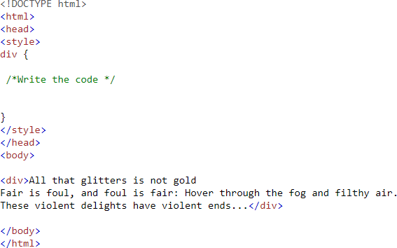
  - Set the margin of the div to "25px".
  - Set the border of the div to "25px solid navy".
  - Set the padding of the div to "25px".
  - Set the width of the div to "200px".
  - Set the background-color to lightblue. The output should look like below.
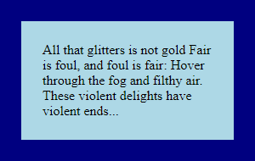

- Write a program to display below
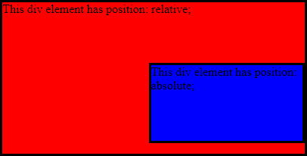

Use CSS position relative and absolute to complete the code.

